**D210 Representation and Reporting**

Nicole Reiswig

College of Information Technology, Western Governors University

Master of Science in Data Analytics

Kesselly Kamara

January 23, 2024

**Table of Contents**

**Part 1: Interactive Data Dashboard**

A. Tableau dashboard 3

**Part 2: Storytelling with Data**

B. Panopto recording 8

**Part 3: Reflection Paper**

C. Reflection paper 8

D. Sources 11

# Representation and Reporting

**Part 1: Interactive Data Dashboard**

A. See the attached interactive tableau dashboard.

1. See the attached csv files churn_clean and population by zip.

2. Instructions for Tableau:

* 1. Visit website tableau.com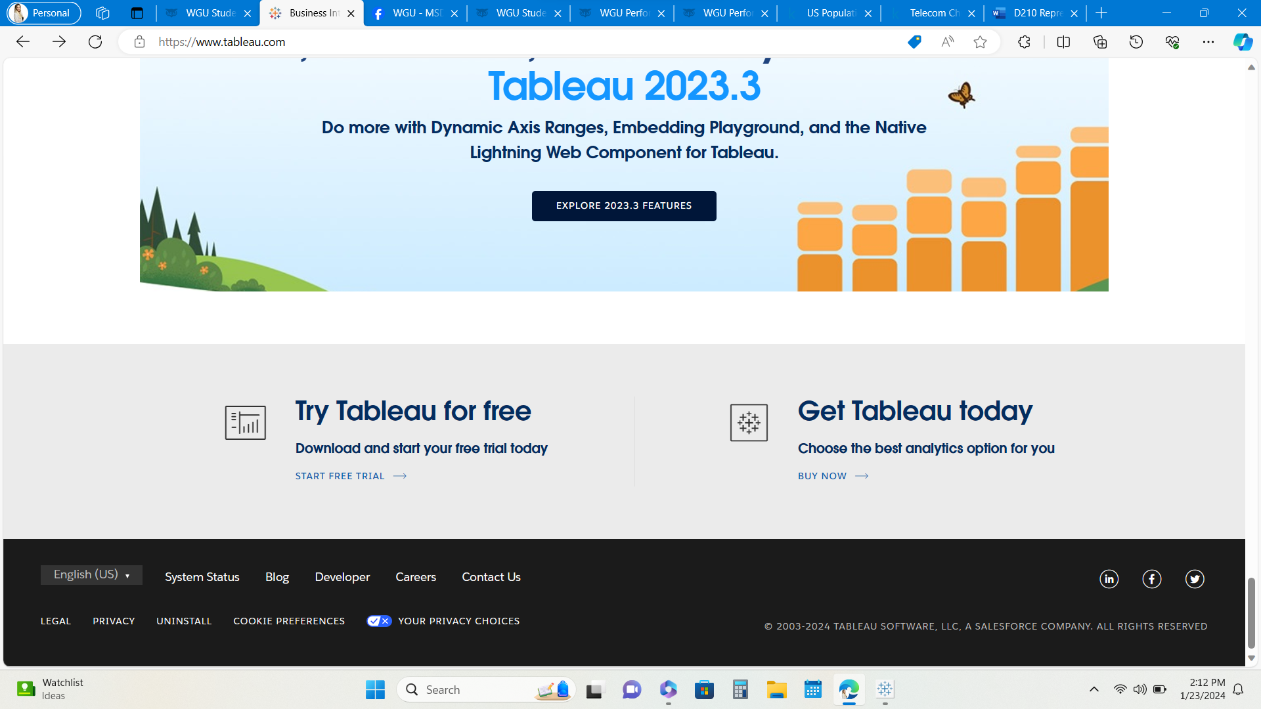
  2. Download tableau for desktop
  3. Follow download prompts
  4. Request student access and create account 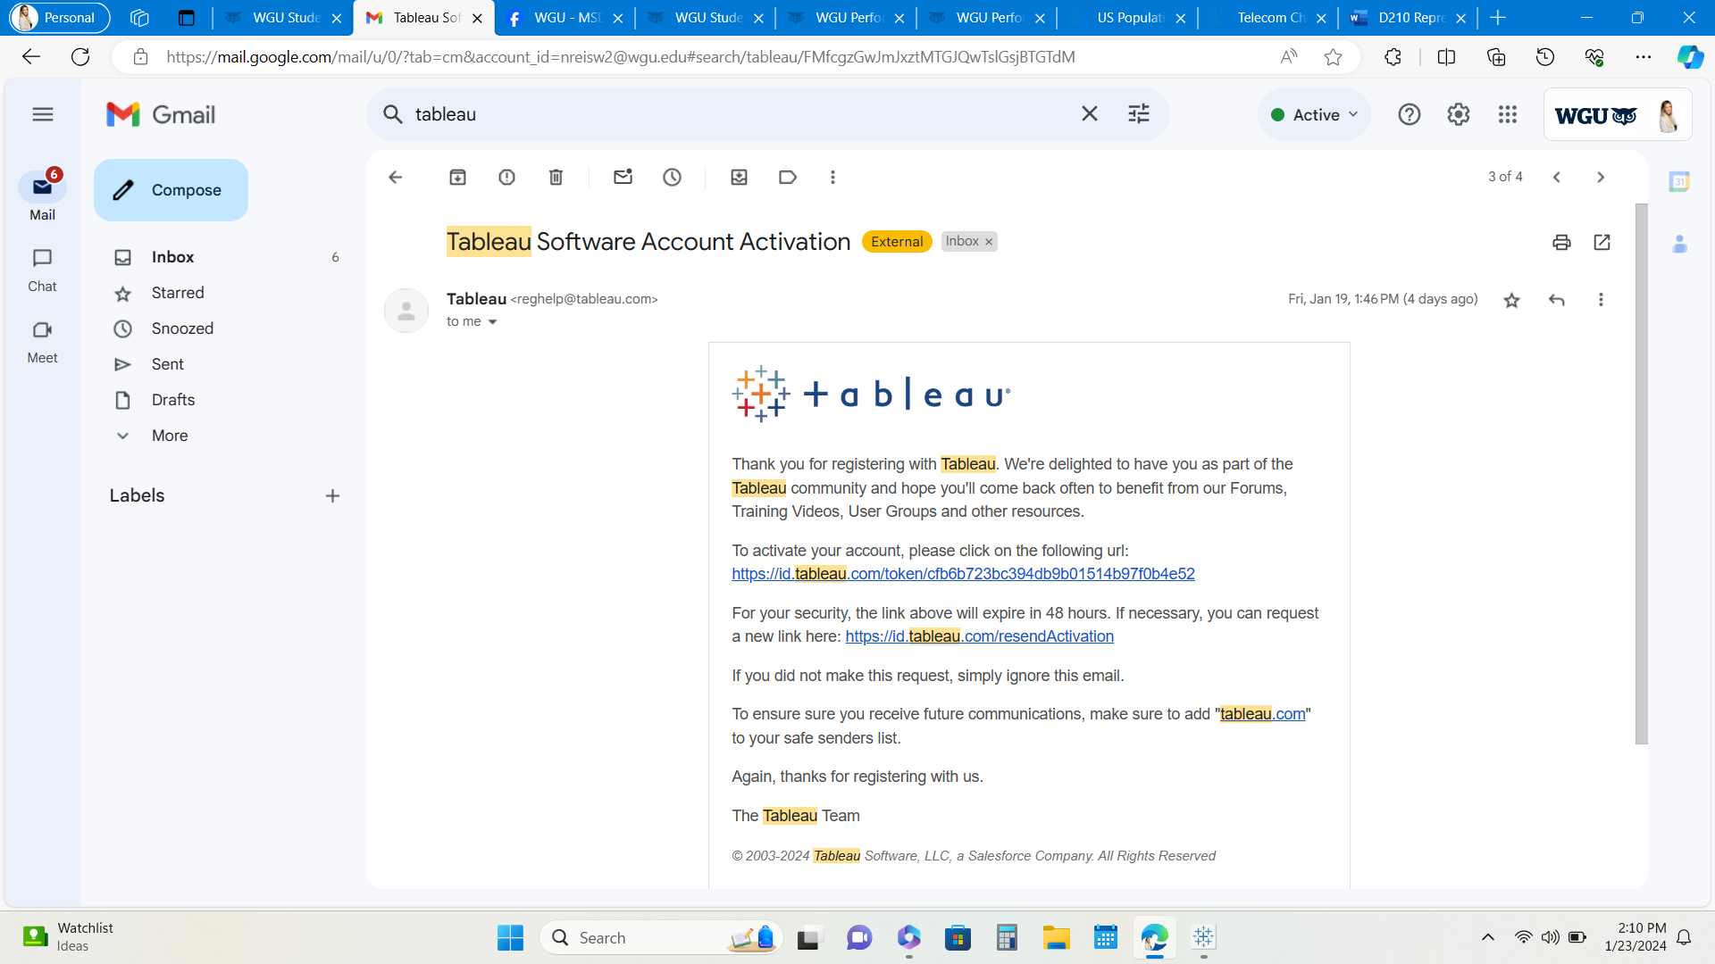
  5. Utilize passcode e-mailed to you to access tableau student for free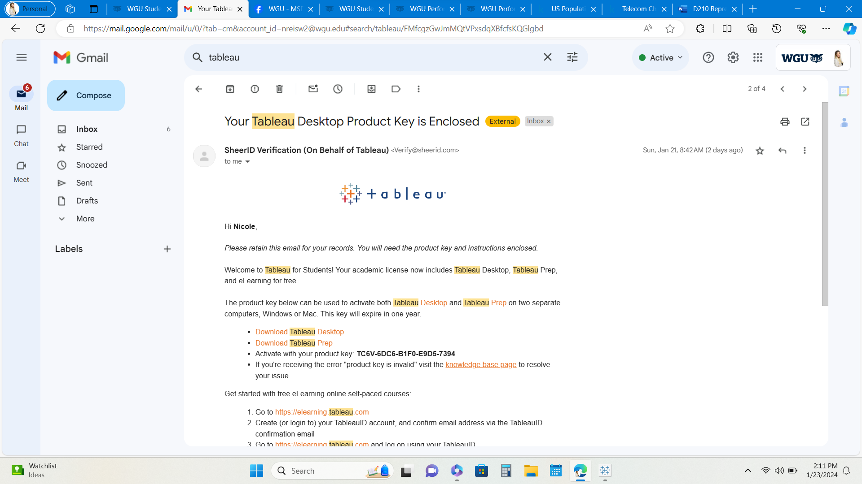
  6. Sign in to Tableau desktop

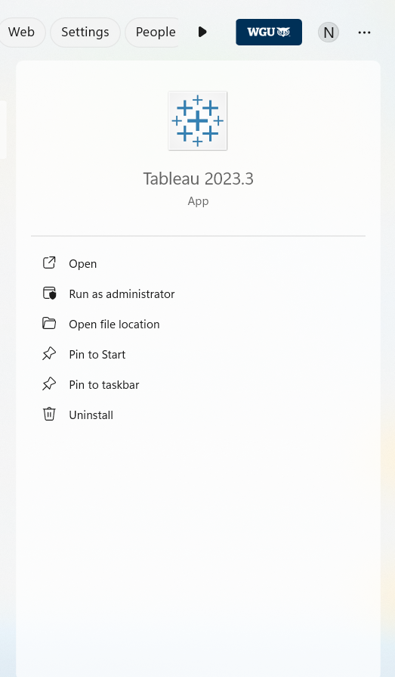

3. Instructions to navigate the dashboard:

* 1. Select the type of file you’d like to utilize from the column on the left. I selected text. 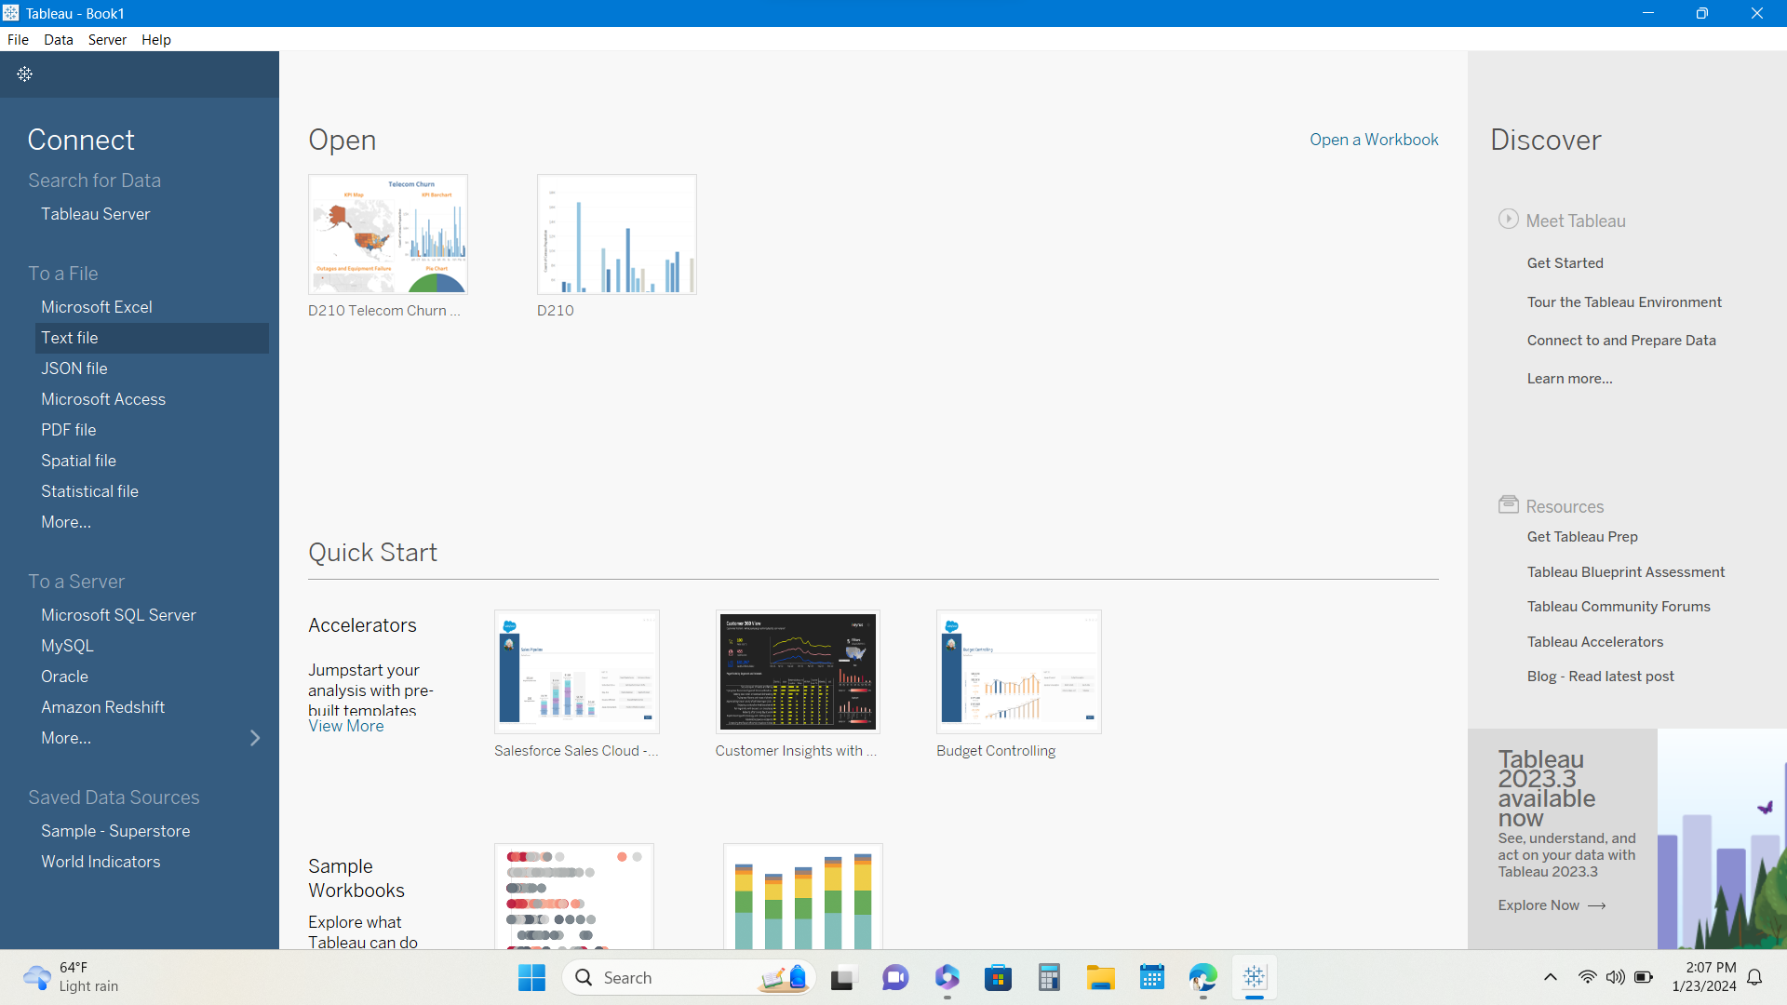
  2. Select the second data source you’d like to utilize. I selected another text file.
  3. Open a sheet from the bottom left tabs and begin creating your visualization. I created 5 sheets with 5 visualizations, 1 on each sheet. 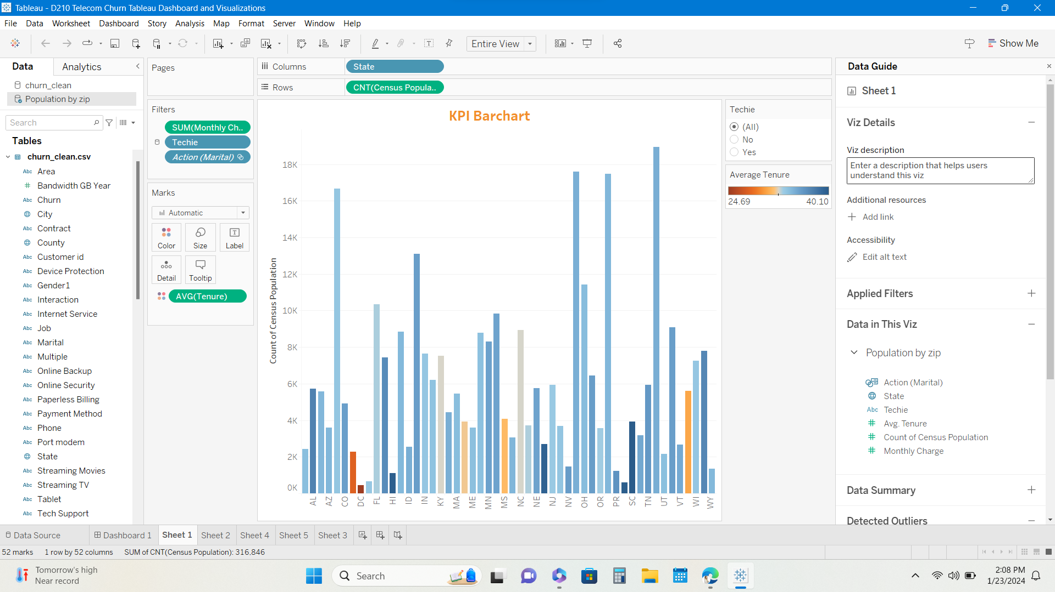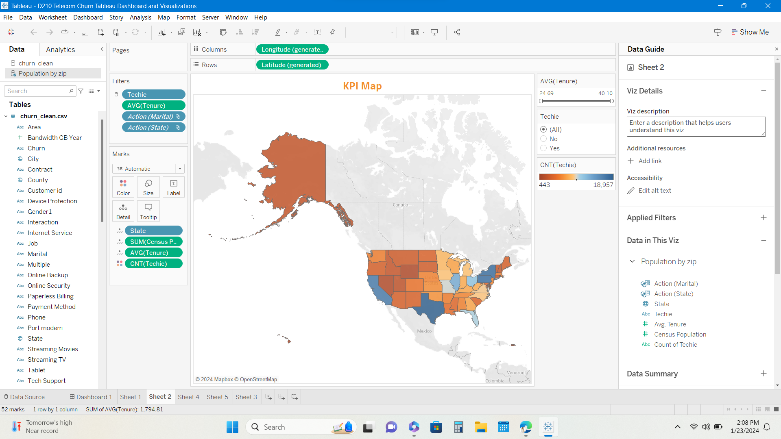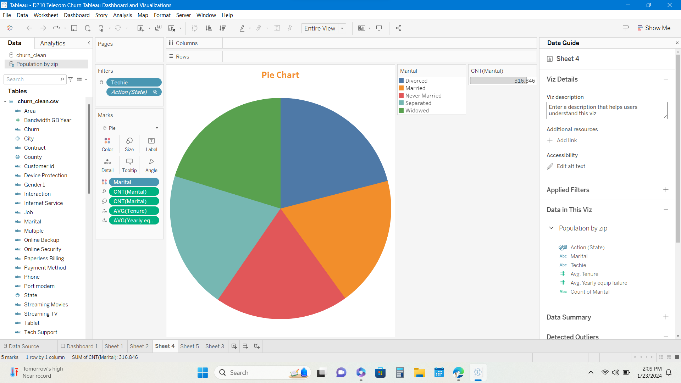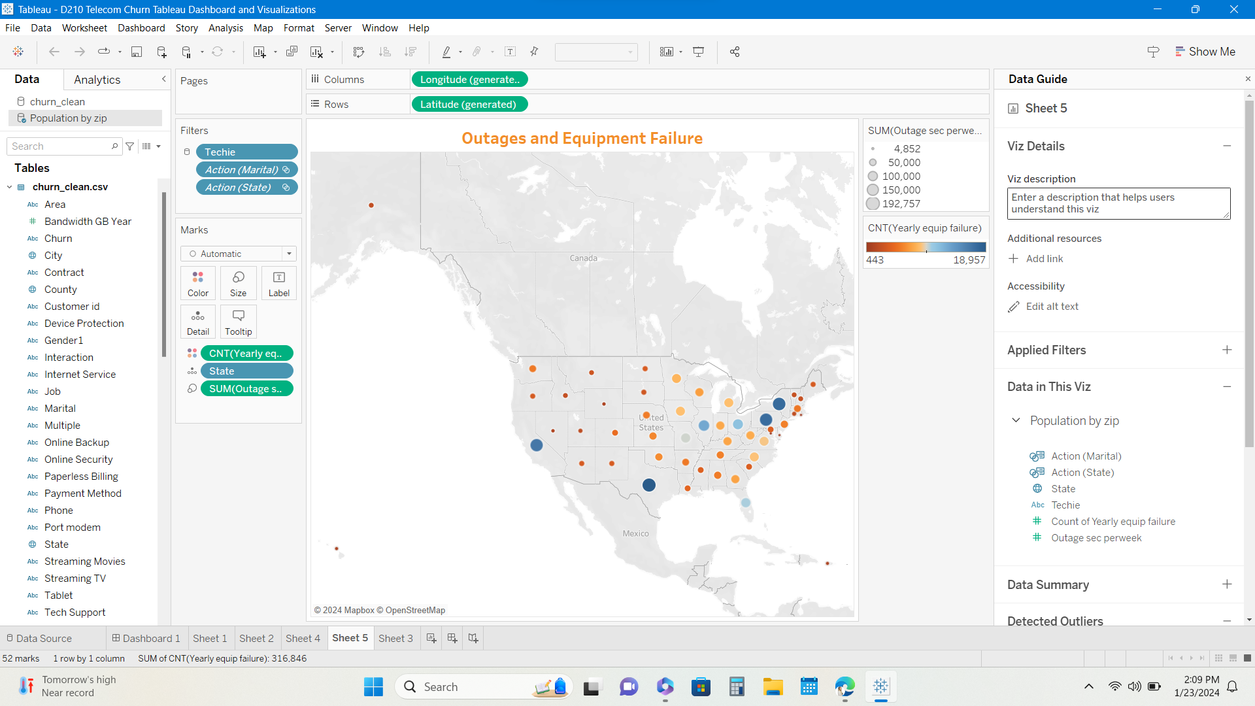
  4. Open a dashboard from the bottom left tabs and then select the sheets from the list in the left column that you’d like to display on your dashboard. Customize to create a visually appealing dashboard that meets the needs of your project. 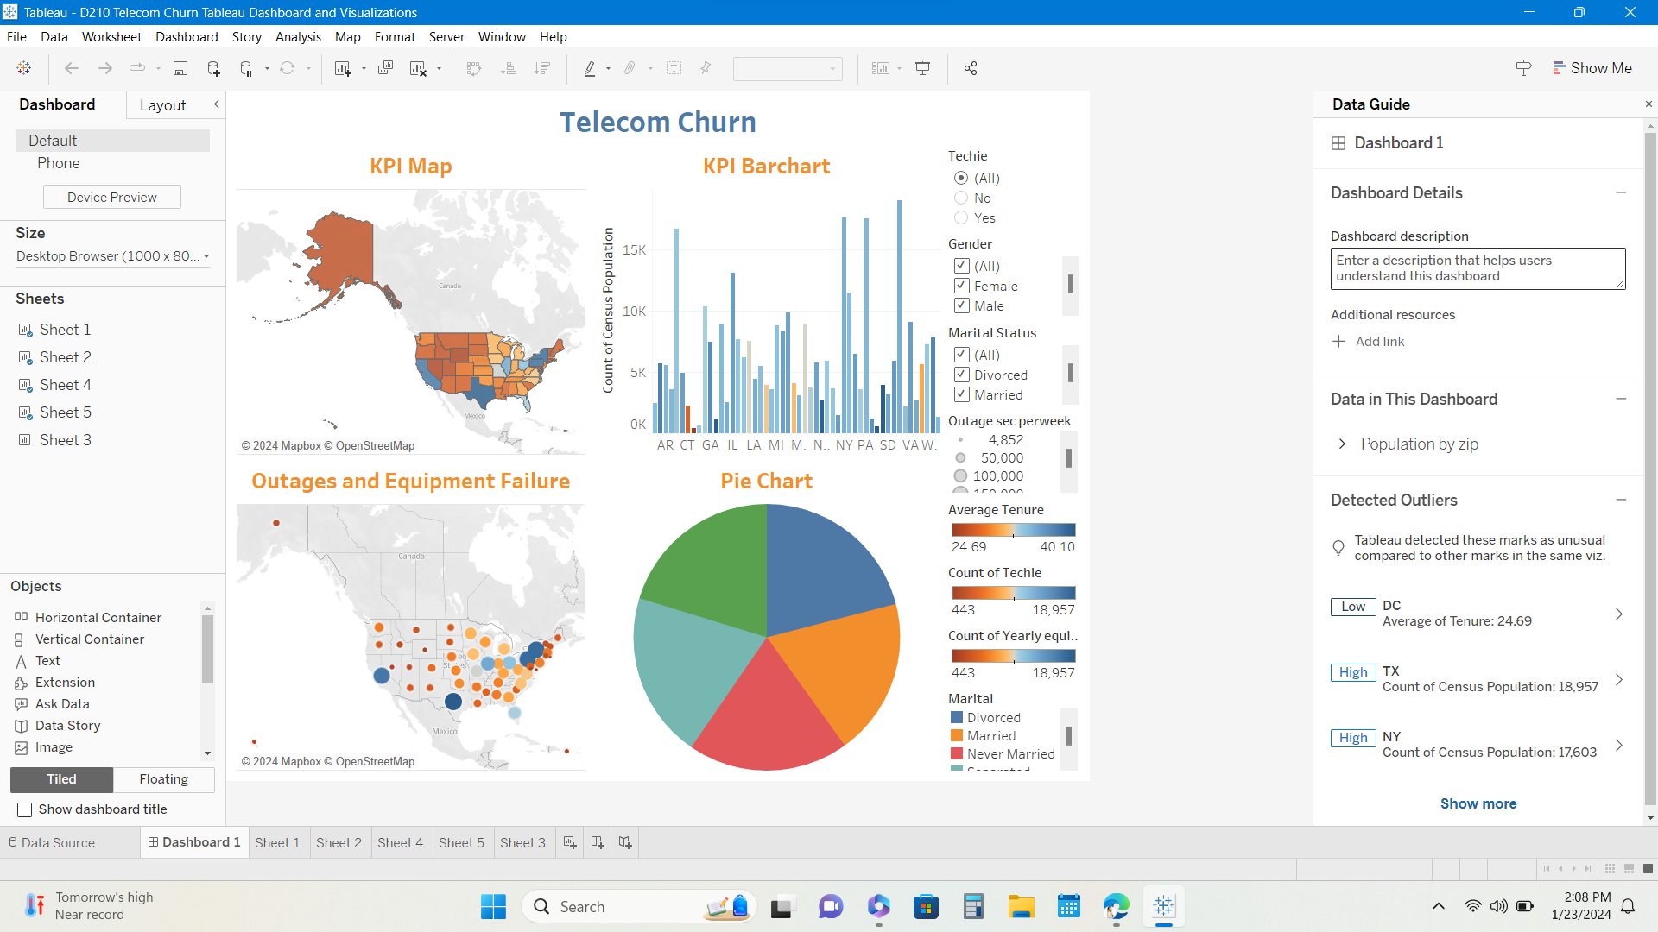

**Part 2: Storytelling with Data**

B. See attached Panopto recording.

**Part 3: Reflection Paper**

C.

1. The goals of the telecom company are to both acquire new customers and retain highly profitable customers. It is more important for the telecom company to retain customers that bring in high profits. This is because it costs 10 times more to acquire a new customer than it does to retain an existing one. The purpose and function of my dashboard align with the needs of the telecom company. In my dashboard, we look at two interactive maps, a pie chart, and a bar chart. In these visualizations, we can compare the total population by census data per area by state and/or zip code and compare it against the total number of customers for the telecom company in the same location. This will help us examine the market for potential new customers we could acquire. We can then further drill down and see the gender, marital status if they are techie, outage seconds, number of equipment failures, and length of tenure. In doing so, we know which states bring in the most revenue, which states have the most errors, which states and individuals are more likely to be long-term customer, and we know exactly who our target market is and can effectively market to the target audience.

2. The variables in the additional data set Census Population by Zip enhance the insights that can be drawn from the Churn_Clean data set because we are able to compare the population of customers by a specified area to the total population according to the census for the same area. This gives us a target audience and we can create business goals for expansion based on this data. We then know the percentage of the market we have penetrated and how much potential there still is.

3. The data representations from my dashboard will assist executive leaders in decision-making by providing insights and data to support the decisions made. One visualization provides data on the number of outage seconds per week for each state and the number of yearly equipment failures. Another visualization provides data comparing the census population to the telecom customers population and the length of tenure.

4. There are several interactive controls in my dashboard and they each enable the user to modify the presentation of the data. For example, you may select “All”, “Female”, “Male”, or “Nonbinary” and the dashboard will give you only the details that relate to that gender, including but not limited to the length of tenure, equipment failures, etc. Another example is the survey question customers answered as to if they consider themselves tech savvy. You may compare all techie individuals' stats to all non-techie individuals' stats, including but not limited to length of tenure and number of equipment failures or outage seconds per week.

5. I built my dashboard to be accessible for individuals with colorblindness by utilizing color schemes that individuals who have colorblindness are still able to identify, a range of blue and reds.

6. The map chart and the bar chart data representations in my presentation support the story I wanted to tell because it gives us the ability to see the markets that we have the potential to penetrate. There is room for improvement and increasing revenue. These visualizations give us the KPI data to make business decisions to do so. In both charts we compare the population from the census to the population of telecom customers and look at the specifics of these customers.

7. My audience is a team of data scientists. I utilized audience analysis by understanding that my team will have some knowledge and understanding of data and software being utilized. If this were a presentation to the company CEO, I would have gone more in depth into the software and its functionality.

8. I designed my presentation for universal access by all audiences by creating visuals that can be seen by audiences who may have colorblindness. I created my dashboard with titles, fonts, colors, graphics, filters and legends with the audience in mind. I have an audio/video presentation of my data for audiences who prefer audio presentations. The dashboard was created to be interactive so that the data can be catered to specific business questions or a broad range of questions.

9. Effective story telling according to LinkedIn have several steps. One is understanding how stories work. You must spin the yarn before you weave it. Next, include key story elements such as structure, plot and conflict. To engage your audience, you must know who your audience is. Including visualizations is an important step. Lastly, encourage action and practice caution. Two elements of effective storytelling that I implemented in my presentation were to spin the yarn and then weave it. I started by explaining my data and then explained how it answered business questions. This was intended to engage the audience by giving them context for the data presented and how it is relevant to them. Next, I included visualizations also to provide context and easier understanding of the figures they were given.

D. No sources were cited in the creation of this paper.

[US Population By Zip Code (kaggle.com)](https://www.kaggle.com/datasets/census/us-population-by-zip-code)

<https://www.kaggle.com/datasets/census/us-population-by-zip-code>

<https://lrps.wgu.edu/provision/258016947>